**CSC4350 Business Case Template**

Team Name: _______The Best Group______

Team Members: ____John, Rodrigo, Anahi__

Prepared For (Customer Name):_______Aurora University_____

Date: _______10/09/2019_________

Project Name: ___Inventory Management____

The business case should be from the perspective of the overall business that is requesting the product or service. It should consider several alternative solutions and recommend the best course of action for that business. In CSC4350’s case, this means you should consider either was is best for Aurora University or Kane County IT staff. You should assume that your solution will be developed, deployed and used for several years (at least 5). So that means, you need to address costs and maintenance process after you have graduated and left the university. For example, how can your recommendation be supported and how much with that cost?

In addition, you must present your results to class and the customer.

**CSC4350 Business Case**

1. **Executive Overview –** *Provide a summary of the opportunity and recommendation to management that gives them enough information to make a decision.* 
   1. *Describe briefly the problem/opportunity (what issue/need will resolve). What will be gained by this project from the customer/organizational perspective?*
   2. *Specific solution and rationale for selecting it (especially business rationale) . In particular, why this solution over any other. How does your solution compare to the other alternatives?*
   3. *What is the bottom-line cost and benefit of selecting this solution? That is how much will it cost and what specific benefits will this solution provide?*
   4. *What are the major risks in this project from the overall business standpoint and how to do plan to overcome them?*
2. **Key Objectives –** *Keep track of items used for*
3. **Business Context –** *The current environment is not very well documented. Currently, the professor will keep a general count of the inventory and what items are present. The only items currently being tracked continuously are the medications.*
4. **The Business process will not change at all.** *The only difference will be the students or professors will now scan out items when taking them out of inventory.*

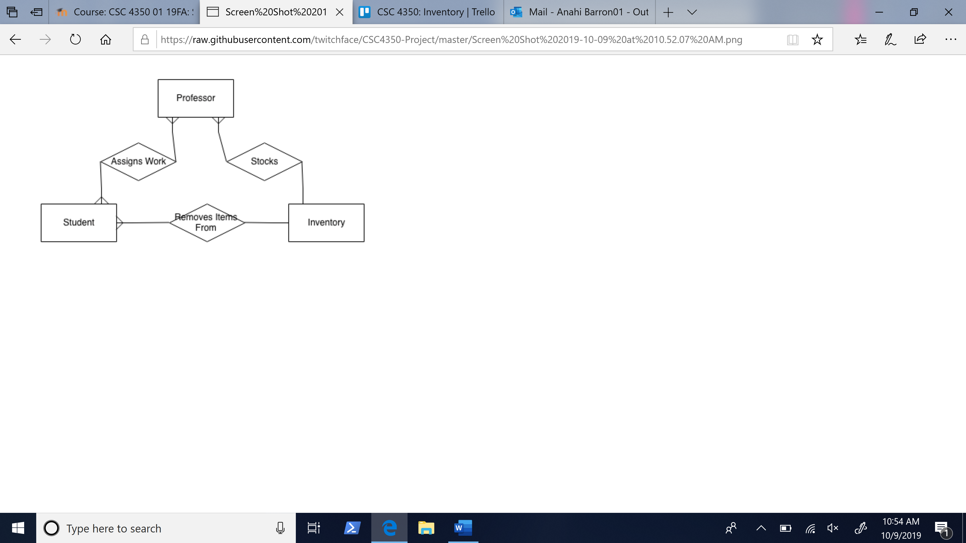

**Opportunities that this will address –**

1. *The biggest capability of this inventory management tool is that will allow the expansion of tacking inventory items in a more accurate way.*
2. ***How is this a revenue creation OR a cost reduction case?*** *This is a cost reduction case because by scanning the majority of items in and out of the system it will reduce waist and redundancy.*
3. ***If this is an innovation case, describe the transformative sources of competitive advantage?*** *Even though this is not an innovated idea the process will help increase the quality of the nursing department at AU*
4. ***When this project is complete, what new capabilities will you provide that will help the business?*** *As I stated before the larges benefit of this project will be the time saved and potential financial savings.*
5. **Critical Success Factors -** *List key things must happen to be successful. This might include specific criteria, sponsorship or other resources needed. For example,* 
   1. *Items must be able scanned in an out with a 99 % accuracy*
   2. *We will need permanent server space in the aurora university server site.*
   3. *Need to be able to print labels that match the scanning system*
   4. *Needs to be only accessible by the nursing department personal.*

1. **Recommended Solution and Solution Details –***Provide an overview of the recommended solution and then specific details about the solution*

* *E.g., We will develop a custom-made solution using mysql, ruby on rails with a custom bootstrap front-end. The solution will completely automate the sales bid process from front to start. We expect this development to require 25 weeks with 5 full time developers.*
* *We will develop a custom-made solution web app using SQL, and JavaScript, ReactJS.*

*The solution could completely reduce human error and help keep more accurate inventory with this system.*

*We expect this development to require 10 weeks for our prototype with 3 full time student developers.*

1. **Alternative Solutions and Solution Details –***Provide an overview of the various solutions, describe the solution and provide specific rationale for not selecting it. Provide at least 3 alternatives solutions (beyond the one your recommend), research them, and describe, their advantages and disadvantages and recommendation for that solution. That is provide a specific reason why you either recommend or not recommend the solution. In addition, summarize this analysis in the following table:*

|  |  |  |
| --- | --- | --- |
| *Alternative* | *Description* | *Specific Reason Rejected* |
| *Don’t modify the process* | *Leve process as is currently with paperwork* | *It’s a poor system, not solution school needs* |
| *Buy new fully developed software* | *Research and purchase a prebuilt inventory system* | *Many are too overpriced for the basic needs for the school* |
| *Hire inventory personnel* | *Hire a full-time employee to specifically monitor the inventory around school* | *Extremely expensive to pay an employee for current inventory needs.* |

1. **Cost and Benefits** *– Describe the project’s expected costs and return on investment*

*Costs*

|  |  |  |  |
| --- | --- | --- | --- |
| **Project Costs** | **Details** | **Frequency** | **Amount** |
| **Staffing** |  |  |  |
| **Software** |  |  |  |
| **Maintenance** |  |  |  |
| **Hardware** |  |  |  |
| **3 year projected totals** |  |  |  |

*Benefits*

|  |  |  |  |
| --- | --- | --- | --- |
| **Cost Reductions** | **Details** | **Frequency** | **Amount** |
| **Staffing reductions** |  |  |  |
| **Hardware reductions** |  |  |  |
| **Time saved** |  |  |  |
| **Other** |  |  |  |
| **3 year projected totals** |  |  |  |

*Anticipated Savings over 3 years*

|  |  |
| --- | --- |
| **Benefits** | **Details** |
| **More control over items** |  |
| **Security** |  |
| **Maintenance savings** |  |
| **Other** |  |

1. **Assumptions** *– List any assumptions for the solution. In particular include:*
   1. *We assume the school will buy any necessary equipment(scanners).*
   2. *We assume the school will properly label all inventory items.*
   3. *We assume the school will provide us with the list of inventory they need to keep track of.*
   4. *We assume this system will be used for at least 3 years, and will need to be maintained*

*Be specific E.g., We will use the system for at least 5 years. We will need to hire an intern for 6 months a $20 /hour*

1. **Deliverables –** *what are the intermediate and final products that you will produce. This includes models, documents, prototypes and final product versions*

|  |  |  |  |
| --- | --- | --- | --- |
| ***ID*** | ***Item*** | ***Dependencies*** | ***Timeframe*** |
| *1* | *Process model complete and a mockup/sketch finished* | *Meetings with customer & team* | *10/17/19* |
| *2* | *Design Database table diagrams* | *Receiving all inventory needed* | *10/24/19* |
| *3* | *Version 1 prototype* | *Deliverables 1 & 2* | *12/09/19* |

1. **Final Recommendations –** *Specific conclusions and management recommendations. You will need to justify your recommendations. Why specifically are you making these recommendations. For example, the following is clear but does not specify why. It does nothing to convince management.*

*“We recommend that we begin this development using 3 developers for 4 months. If any assumptions prove false, we may need to reevaluate this business case. “*